Where the self-help helps…
by Sanjay Jaju
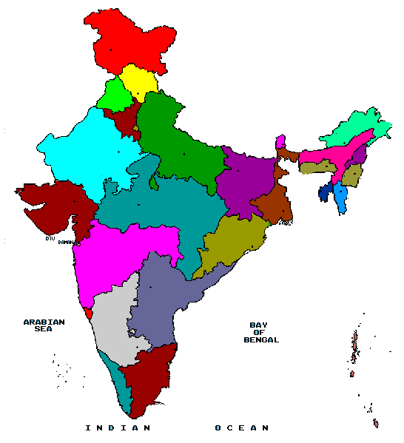
West Godavari
Fig.1 (West Godavari District, Andhra Pradesh (India)
Democracy, as we all learned in high school, has been defined as government of the people, for the people and by the people. While the first two goals have been to an extent met, the true test of democracy lies in it transitioning to being administered by the people themselves. Being the head of the district administration of the eSeva (e services) project, in West Godavari District of the province of Andhra Pradesh in India, I had the opportunity of conceptualizing, implementing and sustaining an initiative wherein information and communications technology have acted as an agent in enabling such a change. We have helped to replace the traditional form of governance and its accompanying deficiencies with a modern, more open, transparent and responsive service delivery system.

The project is a tool to bridge the digital divide in the rural areas and has used Information Technology for providing access to various C2C (citizen-to-citizen) and C2G (citizen-to-government) services to the people living in rural areas. Under this project, web enabled rural kiosks have been established in the villages. The unique thing about these centers is that they are run and managed by women’s self-help (defined here as self-employment and economic empowerment) groups, and have been able to position the rural women as information leaders to help bridge the gender divide.

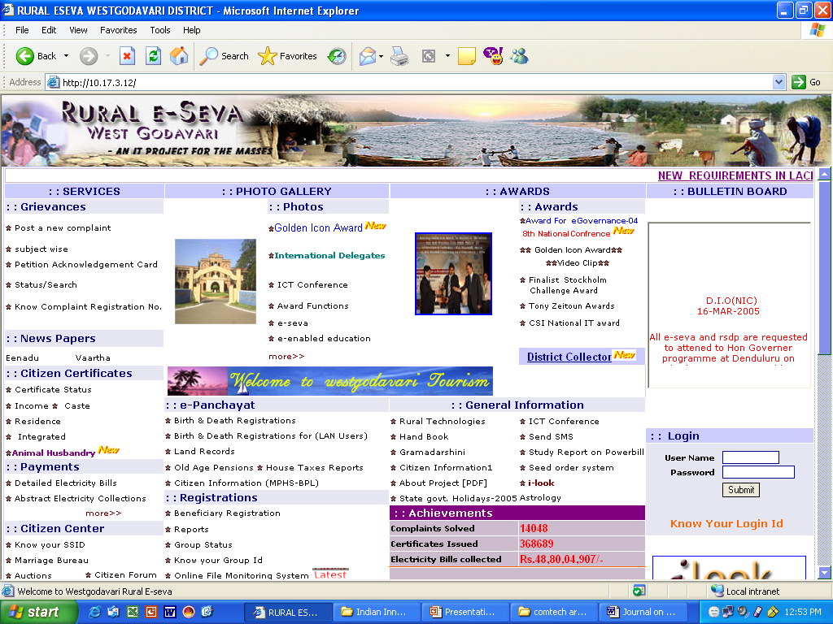

These centers run on a district portal that allows access to various citizen-centric services. These services range from the issuance of various certificates required for getting various social benefits to getting information about various programs. The project allows access to hitherto marginalized communities and therefore helps bridge the existing information gaps.
The computers in the village information kiosks are on a district wide network (a hybrid of dial up, 802.11 and WLL) helping kiosks interact with the district server hosting the local portal. To save on the networking cost, the project has developed a unique synchronization tool that allows the kiosks to work offline and allows the databases to be periodically synchronized in minimal time.
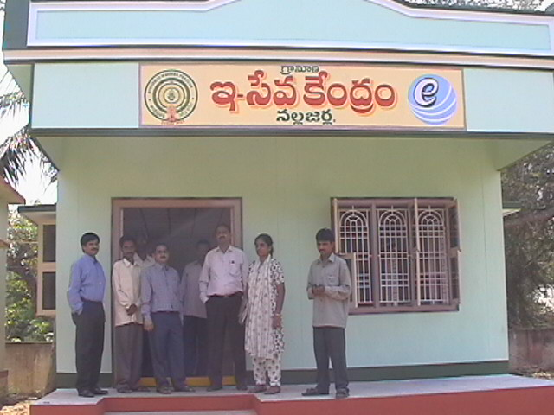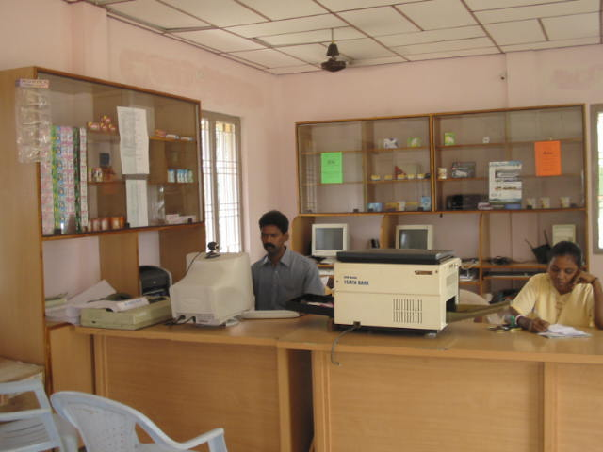
views of e-Seva centres
The project has been developed using local knowledge and local content by local professionals. The development of the portal, applications and tools has been designed for local situations and network speeds. All the kiosks have in turn been handed over to women and youth self-help groups. These individuals have also been trained and have shown remarkable improvement in their skills. The content on the citizen petitions is also in local language. Although roman alphabets are being used currently, steps are on to switch over to the local language fonts.
e-Seva Project Growth
June ‘2002: A pilot ICT initiative to strengthen the self-help groups started in one block of this district.

Nov ‘2002: A comprehensive program to deliver civic services at rural points in convergence with self-employment schemes envisaged and conceptualized.

Jan ‘2003: Web enabled rural kiosks started in 46 places.

June ‘2003: The project getting evolved and institutionalized recording over 300000 transactions by this time.

Sept ‘2003: Partnership with Azim Premji Foundation forged to initiate model whereby children from the elementary government schools can visit the centers daily and use multimedia CDs.

Nov ‘2003: 120 more centers added to the project fold, e-enabled education reaches to over 28000 students, transactions cross 600,000.

July ‘2004: Centers connected through WLL, No of students taking e-enabled education increases to 70,000, centres getting a bigger look and their own buildings

Oct ‘2004: No of Transactions reaches 1.5 million, over 350 million rupees collected against electricity bills.

Nov ‘2004: e commerce activities for tribal tourism and lace park activities launched

Dec’2004: Telemedicine from specialists to the primary health centers started

Jan ‘2005: Transactions cross 2 millions, Project conferred the National Award for exemplary Implementation of eGovernance Initiative Year 2004 ("Gold Icon") under the Innovative Operations and Best Practices – Professional Category by the Government of India.

Feb ‘2005: A strategy titled ‘Closing School’ for intensively training graduate unemployed youth in computers, English and communication and other managerial skills for corporate placement launched.

With over 200 kiosks in the district the project has completed more than 2 million transactions so far. All of these centers are doing good business and are becoming self-sustainable. They are earning anything between $50 to $500 per month. The project has also opened the possibility for the self-help groups to market their products directly. The website has also become a major dissemination and broadcasting tool for the various welfare programs. The project has helped in the creation of a knowledge and information economy thereby bringing in more opportunities and prosperity to the impoverished areas of this district. The project has also induced transparency in the implementation of the government programs and has facilitated weeding out ineligible cases so that corresponding benefits can be passed down to the needy.
The project has won the Gender ICT Award at the GKP Awards night at the World Summit on Information Society at Geneva in December 2003. It also captured the Tony Zeitoun Award in the ICT stories competition in the year 2003. The project has also been nominated for the 2004 Stockholm Challenge Award in e-democracy category. The project has also won the first prize in the National Awards of the Computer Society of India in the year 2003. The project was also nominated in the World Summit Awards in year 2003, the only project in its category from India.

Mr. Sanjay Jaju, Collector & District Magistrate, West Godavari, comes from India’s premier civil service, the Indian Administrative Service, and has done a Post Graduate Programme in Project Design & Management at the University of Manchester in the U.K. He has done his Masters in Thermal Engineering and is also a mechanical engineer.

